Activate and Register Tableau Server

Tableau Server on Windows now includes Tableau Services Manager (TSM), which replaces the Configuration Utility and the tabadmin command line tool

Tableau Server requires at least one product key that both activates the server and specifies the number of license levels you can assign to users.

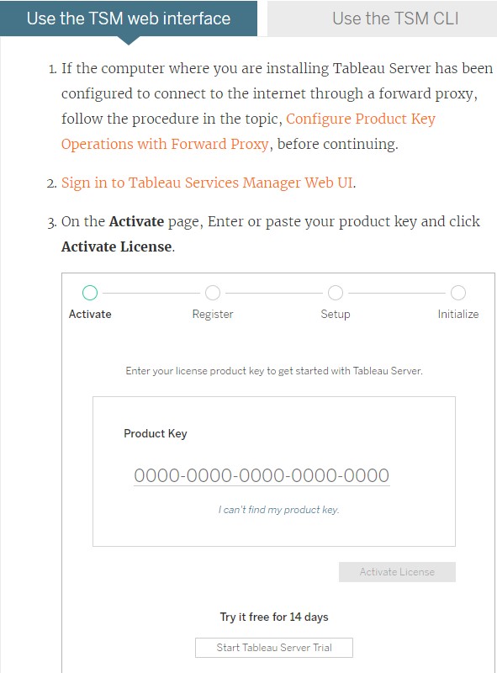

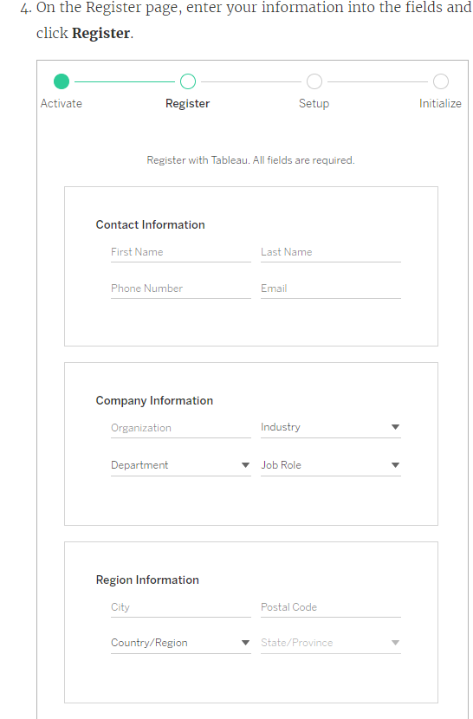

Register.

If you have a product key for Data Management Add-on license, and plan to enable Tableau Prep Conductor.

# Configure Initial Node Settings

Tableau Server on Windows now includes Tableau Services Manager (TSM), which replaces the Configuration Utility and the tabadmin command line tool. If you need help for an earlier version of Tableau Server

Looking for the Tableau Configuration Utility? As of version 2018.2, the Configuration Utility has been replaced by Tableau Services Manager (TSM).

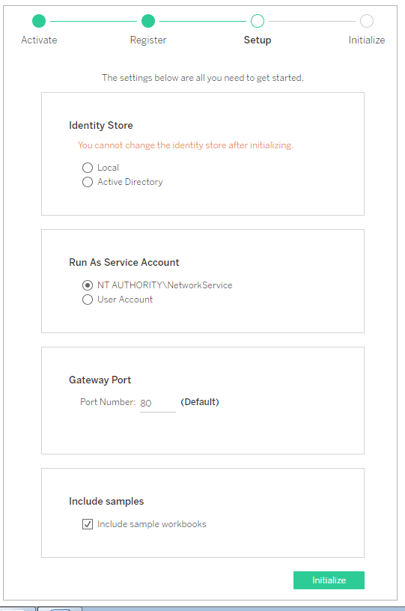

### Identity store settings

You must configure the identity store settings for the Tableau Server computer. The identity store manages Tableau Server accounts. You can configure the identity store to synchronize with an external directory (for example, OpenLDAP or Active Directory) or you can configure the identity store to manage and store accounts on Tableau Server. If you will be using a single sign on solution (OpenID, SAML, Kerberos, etc) then review the following topics before configuring the identity store:

Tableau Server requires an identity store to manage user and group information.  There are two kinds of identity stores: local and external. When you install Tableau Server you must configure either a local identity store or an external identity store.

## Local identity store

When you configure Tableau Server with a local identity store, all user and group information is stored and managed in the Tableau Server repository. In the local identity store scenario, there is no external source for users and groups.

## External identity store

When you configure Tableau Server with an external store, all user and group information is stored and managed by an external directory service. Tableau Server must synchronize with the external identity store so that local copies of the users and groups exist in the Tableau Server repository, but the external identity store is the master source for all user and group data.

If you have configured the Tableau Server identity store to communicate with an external LDAP directory, then all users (including the initial admin account) that you add to Tableau Server must have an account in the directory.

When Tableau Server is configured to use an external LDAP directory for authentication, you must first import user identities from the external directory to the identity store. When users sign in to Tableau Server, their credentials are passed to the external directory, which is responsible for authenticating the user; Tableau Server does not perform this authentication. However, the Tableau user names stored in the identity store are associated with rights and permissions for Tableau Server. Therefore, after authentication is verified, Tableau Server manages user access (authorization) for Tableau resources.

Active Directory is an example of an external user store. Tableau Server is optimized to interface with Active Directory. For example, when you install Tableau Server on an Active Directory domain-joined computer using the [Configure Initial Node Settings](https://onlinehelp.tableau.com/current/server/en-us/config_general.htm#tsm-ui-steps), Setup will detect and configure most Active Directory settings. If, on the other hand, you are using TSM CLI to install Tableau Server, you must specify all the Active Directory settings. In this case, be sure to use the [LDAP - Active Directory](https://onlinehelp.tableau.com/current/server/en-us/entity_identity_store.htm#LDAP) template to configure identity store.

If you are installing into Active Directory, you must install Tableau Server onto a computer that is joined to the Active Directory domain. Additionally, we recommend that you review [User Management in Active Directory Deployments](https://onlinehelp.tableau.com/current/server/en-us/users_manage_ad.htm) before you deploy.

For all other external stores, Tableau Server supports LDAP as a generic way to communicate the identity store. For example, OpenLDAP is one of several LDAP server implementations with a flexible schema. Tableau Server can be configured to query the OpenLDAP server. To do so, the directory administrator must provide information about the schema. During setup, you must use [Configure Initial Node Settings](https://onlinehelp.tableau.com/current/server/en-us/config_general.htm#tsm-cli-steps) to configure a connection to other LDAP directories.

## Authenticating clients

Basic user authentication in Tableau Server is by username and password sign-in for both local and external user stores. In the local case, user passwords are stored as a hashed password in the respository. In the external case, Tableau Server passes the credentials to the external user store and awaits a response as to whether the credentials are valid. External user stores can also handle other kinds of authentication like Kerberos or SSPI (Active Directory only), but the concept is still the same, Tableau Server delegates the credentials or user to the external store and awaits a response.

You can configure Tableau Server such that username-password sign-in is disabled. In these scenarios other authentication methods, such as trusted authentication, OpenID, or SAML can be used.